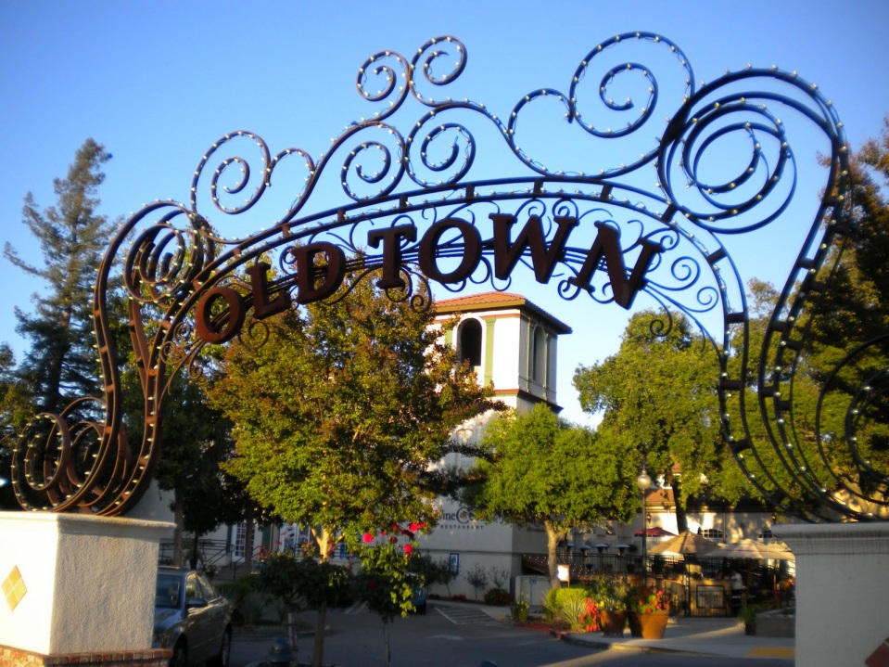

PRSRT STD  
ECRWSS  
U.S. POSTAGE  
**PAID**  
EDDM RETAIL

**Call Me!**

*******ECRWSS*******  
Local Postal Customer

**We Want To BUY a Home In**

**Your Neighborhood!**

**Have You Thought About Selling Your Home?**

We’ve been area residents for several years. We are now looking to purchase a place in the **Subdivision Name** area!

If you’ve considered the possibility of selling your home, we will pay full market value and you can take your time moving out! There are very few homes available in the area so we are willing to pay full price!

Our agent helping us with our home purchase is **Insert Name** **& Brokerage** and we are already pre-approved for a mortgage, so please call/text to discuss a possible sale at: **Insert Phone**



**Have You Thought About Selling Your Home?**

We’ve been area residents for several years. We are now looking to purchase a place in the **Subdivision Name** area!

If you’ve considered the possibility of selling your home, we will pay full market value and you can take your time moving out! There are very few homes available in the area so we are willing to pay full price!

Our agent helping us with our home purchase is **Insert Name & Brokerage** and we are already pre-approved for a mortgage, so please call/text to discuss a possible sale at: **Insert Phone**

**We Want To BUY a Home In**

**Your Neighborhood!**

**Call Me!**